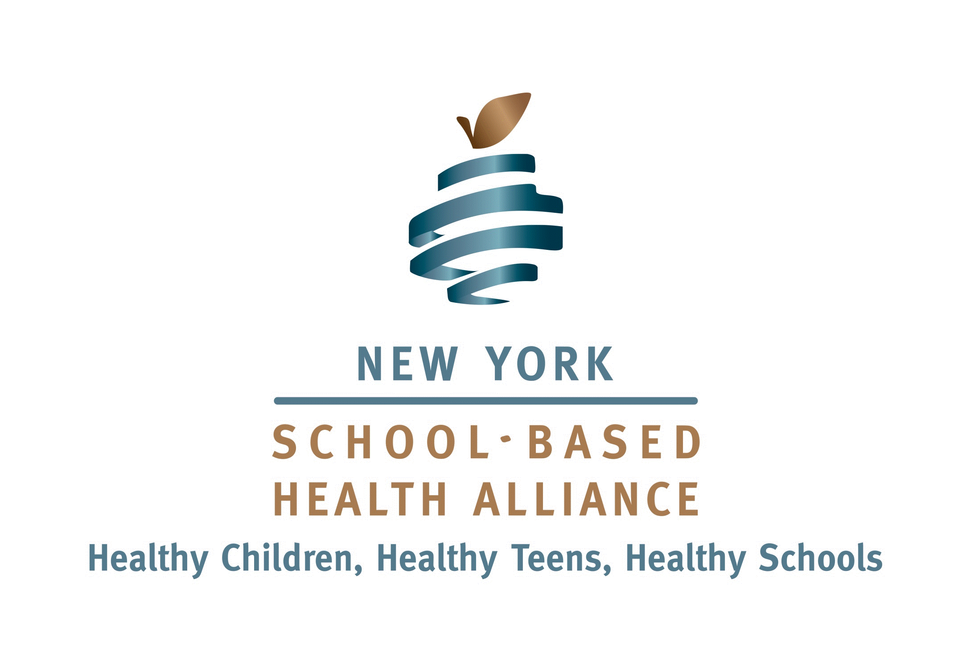
Contact: Sarah Murphy, Foundation Manager
Phone: (518) 694-3423
e-Mail: nysbhfoundation@gmail.com
January 10, 2017
For Immediate Release

NEW ORGANIZATION TO BOOST HEALTH CARE
FOR NEW YORK’S SCHOOL CHILDREN
As New York’s health system undergoes rapid change, the NY School-Based Health Alliance, a membership and advocacy organization representing school-based health centers, has created a new, closely-allied organization to expand and strengthen health care services delivered to New York State’s school children--the NYS School-Based Health Foundation.
Currently some 240 school-based health centers (SBHCs), located in urban, suburban and rural New York, serve over 200,000 school-age children. Authorized by the NYS Department of Health, they are operated by licensed health care professionals and sponsored by community health centers, hospitals and other providers.
“School Based Health Centers are designed to help improve the physical, oral, social, emotional and behavioral health of students because healthy students make better learners,” said Dr. Viju Jacob, Alliance Chair and Assistant Vice President and Associate Medical Director at Urban Health Plan in the South Bronx.
“School-based health clinics offer affordable and convenient access to critically needed health services—right in the children’s own schools,” said NYS Senator James Seward, a longtime supporter of the school-based health model. “These centers are a great way to start young people on a path of preventative care and are a major assist to parents. Nurturing this program and expanding it to more schools will mean healthier children and lower overall health care costs.”
The mission of the Foundation is to fund education and research endeavors to increase understanding of the school-based model; promote growth and expansion of school-based health centers; and improve access to comprehensive services for all children and youth in collaboration with the New York School Based Health Alliance.
“New York’s School Based Health Centers provide important care to at risk youth right in their schools," said Senator Kemp Hannon, Chair of the Senate Health Committee. "This translates into healthier kids who can take better advantage of the learning environment. Creation of this new Foundation can help maintain, strengthen and expand this important program. “
"SBHCs are a proven model of care that increases access to primary and preventive health care and mental health services on-site in schools for children and adolescents,” said Assembly Health Committee Chair Richard N. Gottfried. “The Foundation will help advocate for and build on this invaluable part of our health care and educational systems.”
Leading the new organization are Board Chair Ronda Kotelchuck, former CEO of the Primary Care Development Corporation; and Board members Margee Rogers, Director of Primary Health Care at the Montefiore School Health Program; Martha Wolfgang, Lecturer, Health Policy and Management, Mailman School of Public Health at Columbia; John Mathew, Managing Director at Xerox Corporation; Andrew Loose, Director of Corporate and Foundation Relations at Montefiore Medical Center; John Billings, Professor of Health Policy and Public Service at NYU’s Wagner School of Public Service; Kim Urbach, Assistant Professor of Clinical Nursing at University of Rochester School of Nursing and SBHC Program Manager; and Foundation Manager, Sarah Murphy.
# # #

